|  |
| --- |
|  |

Hogeschool van Arnhem en Nijmegen – Faculty of Engineering

**S4 - Baby Patient Simulator Project – Basic Life Support for Infants**

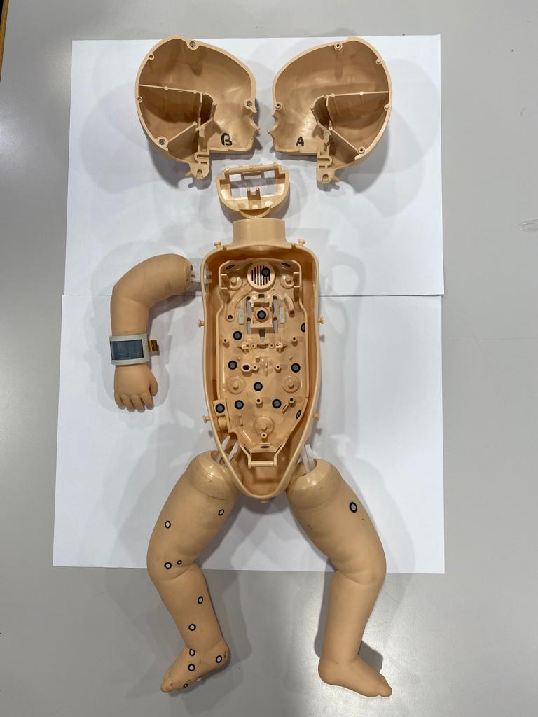

|  |
| --- |
|  |

|  |  |
| --- | --- |
| Johan Korten | Product Owner |
| Peter Bijl | Tutor ESE |
| Matthijs Kwak | Tutor IDE |
| Youri Lucker | Industrial Design and Engineering |
| Mylo Speijers | Industrial Design and Engineering |
| Sima Zuri | Industrial Design and Engineering |
| Niels Urgert | Embedded System Engineering |
| Marc Sutjipto | Embedded System Engineering |
| Antonios Gkougkoulidis | Embedded System Engineering |

**Deadline of Submission: 10. June 2022**

Table of Contents

1 Short summary 3

2 Introduction 4

2.1 Motivation 4

2.2 Project goals 4

2.3 Approach 5

3 Theoretical aspects 5

3.1 Definitions 5

3.1.1 Infant 5

3.1.2 Basic Life Support 5

3.1.3 Cardiopulmonary resuscitation 5

3.2 Basic Life Support for infants 5

3.3 Cardiopulmonary resuscitation for infants 5

3.4 Role of Baby Patient Simulators for educational purposes 5

4 Scope per course, division of roles and involved parties 6

4.1 Embedded System Engineering 6

4.2 Industrial Product Design 6

4.3 Involved project parties 6

5 User requirements 7

5 Product backlog 9

6 Sprints 9

6.1 Sprint 0 – Orientation and research 9

6.2 Sprint 1 – Prototyping 9

6.3 Sprint 2 – Testing 9

6.4 Sprint 3 – Final product 9

7 Conclusion and outlook 9

8 Literature 9

9 Attachments 10

9.1 Poster 10

9.2 Personal evaluation 10

9.3 Videos 10

# 1 Short summary

# 2 Introduction

## 2.1 Motivation

The usage of Baby Patient simulators is accompanied by many problems. Especially for educational purposes there are many challenges that must be solved to provide a prosperous quality of learning. One of those problems is the expensive price of manikins with a realistic feedback functionality[1]. In contrast cheap Manikins cannot provide this vital realistic feedback in the context of Basic Life Support[2]. Furthermore, the companies manufacturing manikins with Basic Life Support and realistic feedback in mind treat the entire manikin as a black box system, so if a malfunction to one of the subsystems happens the entire manikin is decommissioned. Because of those problems it is very challenging to afford manikins with a realistic feedback functionality in a large scale. But how can you design a manikin with a realistic feedback functionality for a cheap price?

## 2.2 Project goals

To find an answer for this question the Research Group Baby Patient Simulator tries to design a prototype with a realistic feedback functionality with a minimum amount of money and resources. Because of the many involved parties in the Research Group Baby Patient Simulator, every involved group focuses their work on specific parts of the manikin. The S4 group works primarily on designing the airway system and the compression functionality of the manikin. To meet all demands, the project is divided into four phases. In the first phase the project group will mainly work on research aspects of the project like Basic Life Support and CPR. The goal of the first phase is to get an overview about the topic of the project. In the second part of the project the focus is set mainly on prototyping and gathering ideas for the airway system and the compression part. The goal of this part is to create a prototype on which the project group can make further work on. The third phase is about testing and integrating the components that are necessary to design a proper compression and airway system. The intention behind that is to find out which components should be used and where there should be placed within the manikin. In the last part of the project the group tries to merge all results from the previous phases such that in the end there is a deliverable product.

## 2.3 Approach

For the first part of the project the S4 group will mainly analyse literature to get confidential information about Basic Life Support, CPR and realistic baby manikins with feedback. To achieve the goal of the second phase, the results from the previous project groups will be analysed and evaluated. Based on this information the project group will gather ideas, make sketches, and create their own prototypes for the manikin. For the testing and integration phase the prototypes will be tested and integrated into the manikin by writing test code, making necessary adaptions, and using different materials. In order to deliver a working product and merge all the previous results, the S4 project group will communicate with the other involved project groups and adapt the worked-out airway system and compression functionality if needed. The S4 group will work with the project management method Scrum to organize their project. Other used tools for the project are Arduino, several 3D design programs and a 3D-printer.

# 3 Theoretical aspects

This chapter describes the necessary theory behind the usage of baby patient simulators. For the project it was necessary to gain knowledge about the basic principles of first aid to define which requirements the design of the manikin must fulfil.

## 3.1 Definitions

### 3.1.1 Infant

The project focuses on designing a manikin for an infant. The age interval for infants is defined from the date of birth to one year of age. Hence it is necessary to make sure, that the design of the compression- and air-ventilation system must be drafted for a baby.

### 3.1.2 Basic Life Support

Basic life support describes measures that can be applied to support vital health functions for a collapsed person with no equipment. Vital health functions that can be supported are for instance respiratory and circulatory. Signs that make the usage of basic life support necessary are a heart attack, cardiac arrest and an obstructed airway.

### 3.1.3 Cardiopulmonary resuscitation

CPR describes a concrete tool that is used within basic life support. CPR can be defined as a “lifesaving procedure performed when the heart stops beating”. For executing CPR there are two common approaches. The first version of CPR is laid out for healthcare providers. For this case CPR includes chest compression and mouth-to-mouth breathing. The second approach is laid out to untrained people with a small experience in first aid measures. For this case CPR only includes chest compression and not mouth-to-mouth breathing. Important variables that have huge impact on the success rate of CPR are chest-depth, compression rate and the ventilation.

## 3.2 Basic Life Support for infants

### 3.2.1 Safety, stimulate and shout

Safety, stimulate and shout is a procedure that must be applied first, when basic life support becomes necessary. Safety means that the external environment must be safe for the rescuer and the child in order to perform basic life support safely. Stimulate refers to measures that must be applied to check whether the victim is responsive or not. Concrete measures for stimulation are for instance shaking the arm or the head carefully. Shout describes measures to get external help from medical services like calling the ambulance.

### 3.2.2 ABC – Pattern

The ABC-pattern is an approach that includes several first aid measure to secure vital health functions. The ABC-pattern consists of three parts named Airway, Breathing and Circulation. The first part tries to deal with the airway of a victim. A common problem is an obstructed airway. A reason for an obstructed airway can be a fallen back tongue. To make sure that the airway becomes free again the head tilt/chin lift manoeuvre can be applied like shown in the figure below.

### 3.2.3 CPR

# 4 Scope per course, division of roles and involved parties

## 4.1 Embedded System Engineering

The embedded system engineers in the S4 project group are responsible for working with all kinds of electronics, that must be implemented in the manikin. Electronic components that will be used are for instance sensors, microcontrollers, wires and chips. The main exercise for the embedded system students in this project can be divided into three tasks. First in writing code for the sensors such that those are working properly in the manikin. The second task is testing the sensors with the written code. And finally, all components should be merged together so that the compression as well as the air-pressure can be measured correctly in the manikin.

## 4.2 Industrial Product Design

## 4.3 Involved project parties

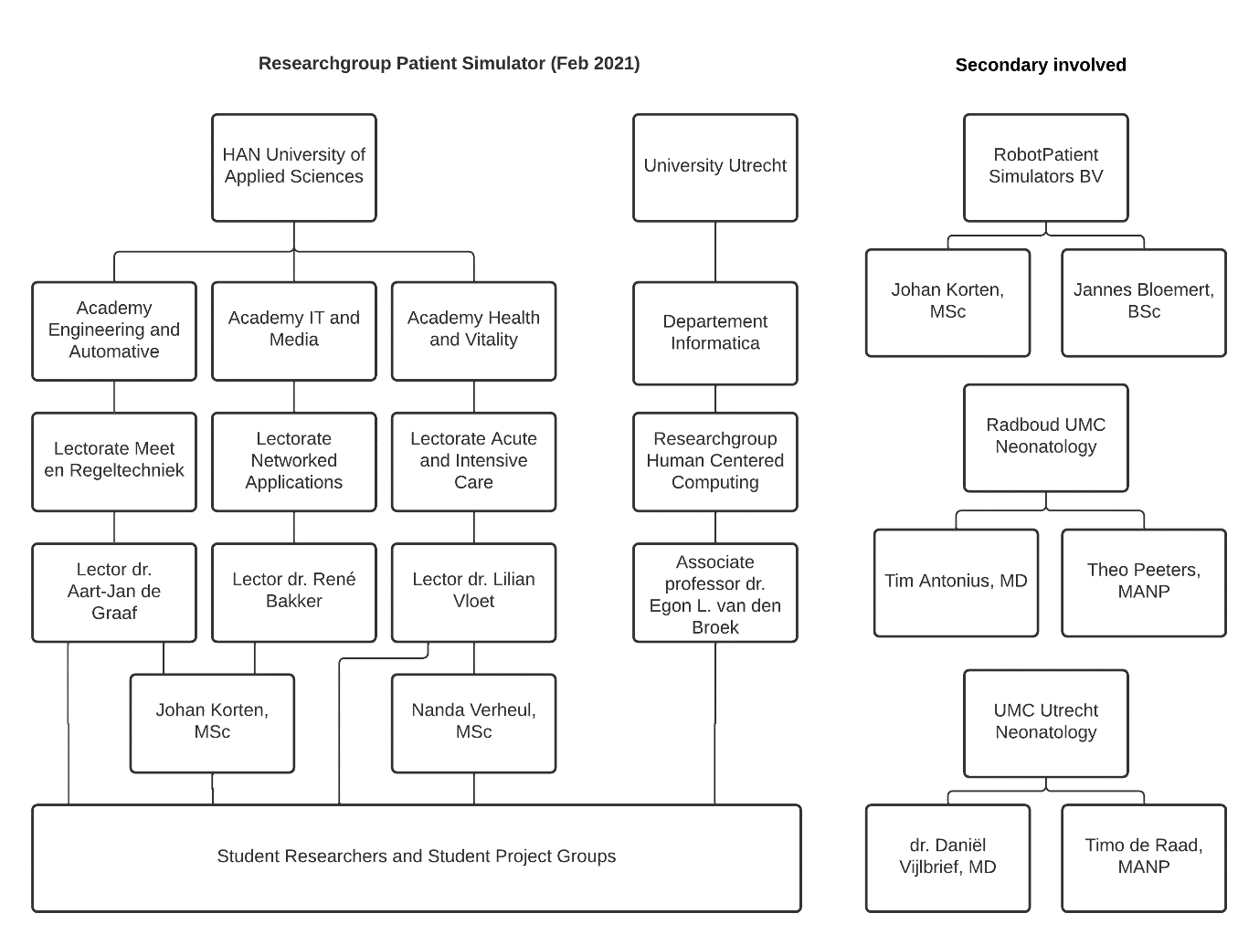

# 5 User requirements

|  |  |  |  |  |  |
| --- | --- | --- | --- | --- | --- |
| **Nr.** | **Requirement** | **Unit of measurement** | **Source** | **Date** | **Verification** |
| **Group 1** | **Measuring Ventilation** |  |  |  |  |
| 1.1 | Measures an Air volume of 15 to 25.5 mL. | mL |  | 14-2 | Measure the air volume |
| 1.2 | Measure if the ventilation rate is 8 to 10 breaths per minute. | min-s | ​​(CPR Guidelines – Infant, 2006)​ | 14-2 |  |
| 1.3 | Measures the pauses between ventilations | - |  | 14-2 |  |
| 1.4 | Check if the first responder is trying to ventilate the baby but the airway is obstructed |  |  |  | Use a pressure sensor in the mouth and compare the value given to a pressure sensor in the lungs |
| **Group 2** | **Measuring Compression** |  |  |  |  |
| 2.1 | The user is compressing or releasing the manikin (Chest recoil). | - |  | 14-2 | ToF sensor or equivalent |
| 2.2 | The compression depth is 1/3 of chest, about 4 cm for babies. | cm | ​​(NHS, 2019)​ | 14-2 | ToF sensor or equivalent |
| 2.3 | The centre of the thorax and lower half of the sternum is pressure sensitive, to ensure that the responder is doing compressions at the right spot. | - |  | 14-2 | Pressure sensor |
| 2.4 | Compression rate is between 100-120 times per minute. | min-s |  | 14-2 | ToF sensor or equivalent |
| 2.5 | The compression Duty cycle is 50%. | % |  | 14-2 | ToF sensor or equivalent |
| **Group 3** | **CPR Integration** |  |  |  |  |
| 3.1 | Calculate the Ventilation/Compression Ratio (Must be 2/15) | - |  | 14-2 |  |
| 3.2 | Calculate the proportion of time spent performing chest compressions during arrest. Compression Fraction (CCF) of at least 60% with a goal of ≥ 80% | % |  | 14-2 |  |
| 3.3 | Monitoring that CPR is maintained for at least 2 minutes | min-s |  | 14-2 |  |
| **Group 4** | **Reliability** |  |  |  |  |
| **4.1** | The manikin must work at least 6 months of daily use before anything breaks. *In this case daily use means that the main functionalities like the compression and ventilation training can be carried out for ...* | months |  | 14-2 | Test end product within 6 months of use. |
| **4.2** | All the parts that are removeable need to be replaceable by the users. | - |  | 14-2 |  |
| **Group 5** | **Product requirements** |  |  |  |  |
| **5.1** | There is a way to turn the manikin on by a switch that is visible. | - | ourselves | 14-2 | test visibility of on-off switch |
| **5.2** | There should be a sound/feel confirmation of the manikin turning on. So, the teacher knows the manikin is working. | - | ourselves | 14-2 | Turn the mannequin on and feel/hear for the confirmation. |
| **5.3** | The inner body of the thorax will be compressed about 100-120 times per minute and will also get released 100-120 times per minute. This means that the inner body needs to be on its original height within 0.25 to 0.3 seconds after a compression. | seconds | ​​(Korten, et al., 2022)​ | 14-2 | Compression-test, measure the height of the thorax. |
| **5.3.1** | If the user is doing compressions faster than this time period, he/she will experience that the thorax isn't completely up yet. |  |  |  |  |
| **5.3.2** | If the user is doing compressions slower than he/she should there will be audio/visual feedback for the user. |  |  |  |  |
| **5.4** | There is an indicator for the position of fingers placement with feedback for the user. Because the finger placement is crucial when performing BLS. | - | ​​(Korten, et al., 2022)​ | 14-2 | Compression-test, visibility of the position for the fingers |
| **5.5** | There should be feedback if the chest compressions don’t reach a compression depth of at least 4 cm or exceeds 6 cm. So, the user will learn the correct compression depth. | cm | ​​(Korten, et al., 2022)​ | 14-2 | Compression-test, feedback on depth. |
| **5.6** | The thorax will be compressed about 100-120 times a minute, so the thorax needs to be able to handle about 130 compressions a minute. | min-s | ​​(Korten, et al., 2022)​ | 14-2 |  |

# 5 Product backlog

# 6 Sprints

## 6.1 Sprint 0 – Orientation and research

During the first sprint, we wanted to get acclimated with the medical literature behind medical manikins and BLS. We then focused more on the features provided by other manikins, and how the current BPS manikin is working. After finishing our research, we started creating a table of user requirements in communication with our tutors, and ways in which we can implement those requirements to the manikin. We also made a functional design, outlining the implementations we want to make. Our design ideas mainly focused on creating a compression and ventilations sub system with sensors, the mechanical feedback of the chest, the redesign of the head so we can fit the battery pack that provides power to all electronics on the manikin, the mounting plate of the body and the airway system.

## 6.2 Sprint 1 – Prototyping

During the prototyping stage, we started implementing our ideas from the functional design.

### 6.2.1 The head

For the redesign of the head, we used a 3D scanner to scan the head of the current BPS manikin, and then used that scan as a base to make our own design. We started by removing the mounting mechanisms to save space.

For the mechanical feedback of the chest, we first thought about possible materials we could use to mimic the compression and rise of the chest that an actual infant will have. From literature we knew that foam was a good option, but we also wanted to try different 3D designs with PLA.

For the compression sensor subsystem, we used the VL6180X Time of Flight (ToF) sensor based on the research made by the Semester 3 group 2021-2022. The sensor emits light from a laser source and measures the time it takes for the light to reflect and come back. This way, we can measure the

## 6.3 Sprint 2 – Testing

## 6.4 Sprint 3 – Final product

# 7 Conclusion and outlook

# 8 Literature

# 9 Attachments

## 9.1 Poster

## 9.2 Personal evaluation

## 9.3 Videos

## 9.4 Testresults

**9.4.1 Software Unit (I/O Sensors) Test**

**Time of Flight**

* Number of Compressions
* Compression Depth
* Distance

**DLC-01G-U2**

* Operating range: 248.82 Pa

**SDP810-500Pa**

* Operating range: -546 Pa to 546 Pa

**9.4.2 Software Subsystem Test**

Testing VentilationController with two DLC-01G-U2 sensors and one SDP810-500Pa sensor.

Deadlock problem in tasksGatherInput also when all booleans are true and when taskGatherInput is lower priority then other tasks.

When taskGatherInput is disabled, it’s get stuck in idle task loop

**9.4.3 Software System Integration Test**

1.
2.